# Class24: Employees Webpart

# From the last section we had the following half project.

# 

**Open window explorer and Open Finalmaster on visual studio code**

**at IE and simply minimize it**

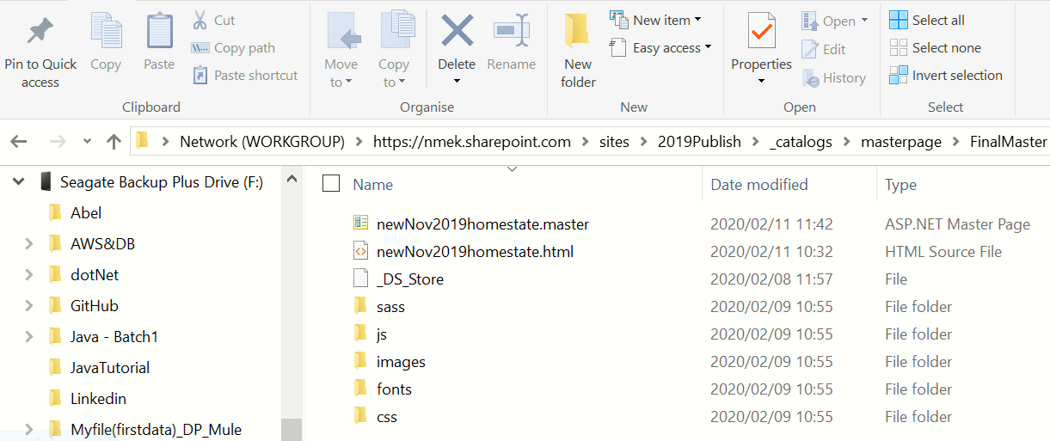

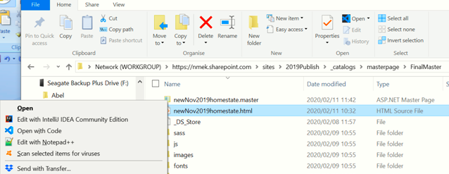

From spoverride.css file,Copy all css under: /*credit to: Denis Molodtsov */ ,

/*credit to: Denis Molodtsov */

.ms-webpart-chrome-title *,

.ms-webpart-chrome-title *:before,

.ms-webpart-chrome-title *:after,

#s4-ribbonrow *,

#s4-ribbonrow *:before,

#s4-ribbonrow *:after,

.ms-webpart-controlBox,

.ms-dialog *,

.ms-dialog *:before,

.ms-dialog *:after,

#idStorefrontLayoutRoot *,

#idStorefrontLayoutRoot *:before,

#idStorefrontLayoutRoot *:after,

.ms-dialog #s4-workspace *,

.ms-dialog #s4-workspace *:before,

.ms-dialog #s4-workspace *:after,

.ms-dlgTitle *,

.ms-dlgTitle *:before,

.ms-dlgTitle *:after,

.ms-srch-result-groups *,

.ms-srch-result-groups *:before,

.ms-srch-result-groups *:after,

#Paging *,

#Paging *:before,

#Paging *:after,

#Hero-WPQ2 *,

#Hero-WPQ2 *:before,

#Hero-WPQ2 *:after,

#suiteBarButtons *,

#suiteBarButtons *:before,

#suiteBarButtons *:after {

-webkit-box-sizing: initial !important;

-moz-box-sizing: initial !important;

box-sizing: content-box !important;

}

=====================================================================================

then paste it our FinalMaster visual studio code in

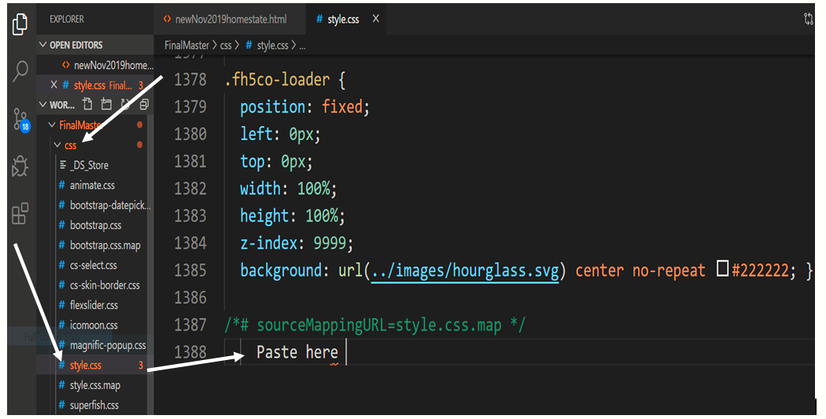

**Then refresh (Ctrl + F5) our project at IE then we get. Make sure FinalMaster is Opened at window explorer**

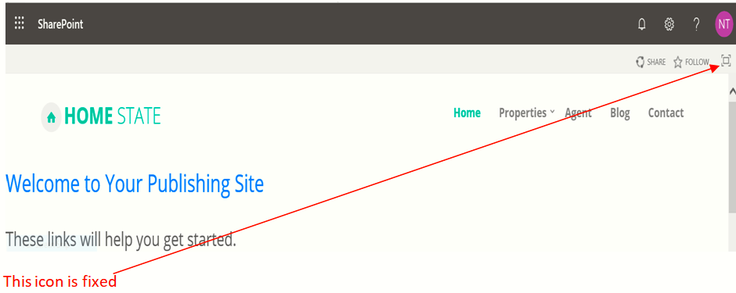

**Still the header section needs some fix**

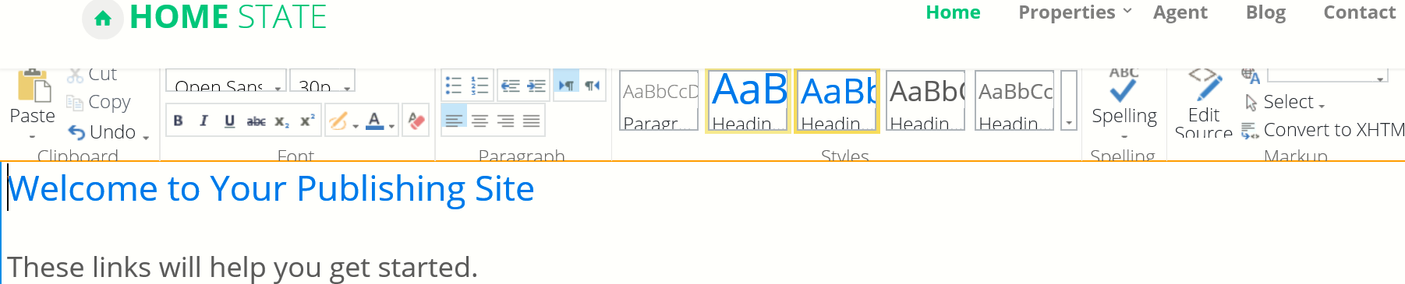

Chrome is preferable.

**Add our first(bellow) CSS at Style.css code and then( Ctrl + F5)**

/* Add some changes by ourselves */

#s4-bodyContainer {

  padding-bottom: 0 !important;

}

**And then we get:the following result some icons are fixed**

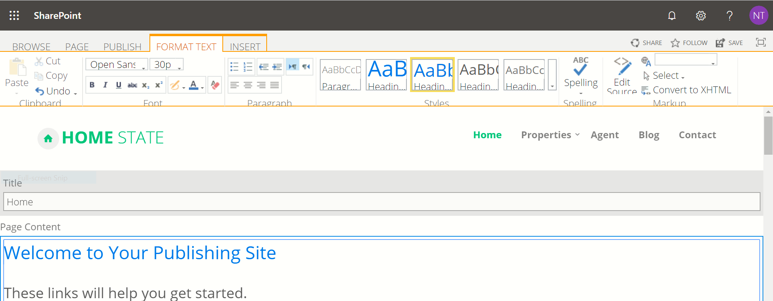

**To show Employees on HR intranet create Custom List named Employees.**

Then:

* Change Title to Full Name
* Create JobTitle => single line of text
* Create ShortDescription => mult- line of text and plain text
* Create Picture => single line of text
* Create Email => single line of text
* Create Phone => single line of text
* Create OfficeNumber => single line of text

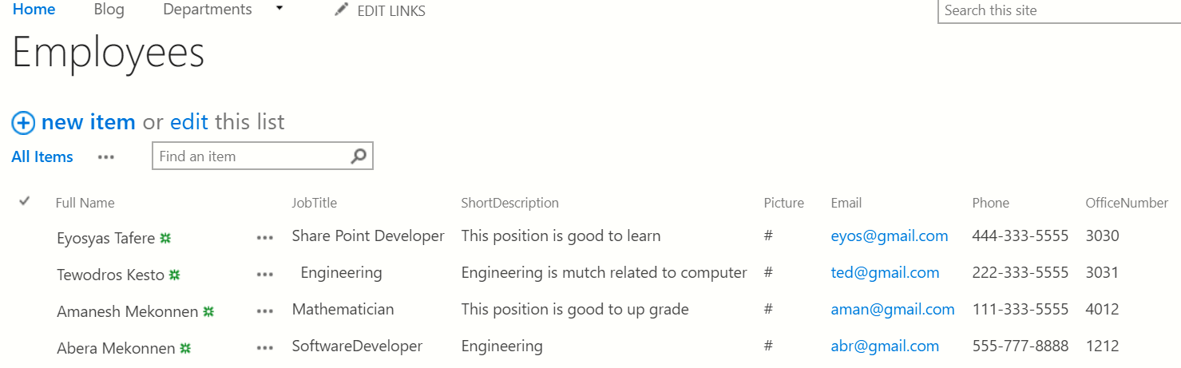

Then we need to do webpart: wich is the same to (our’s team html css)

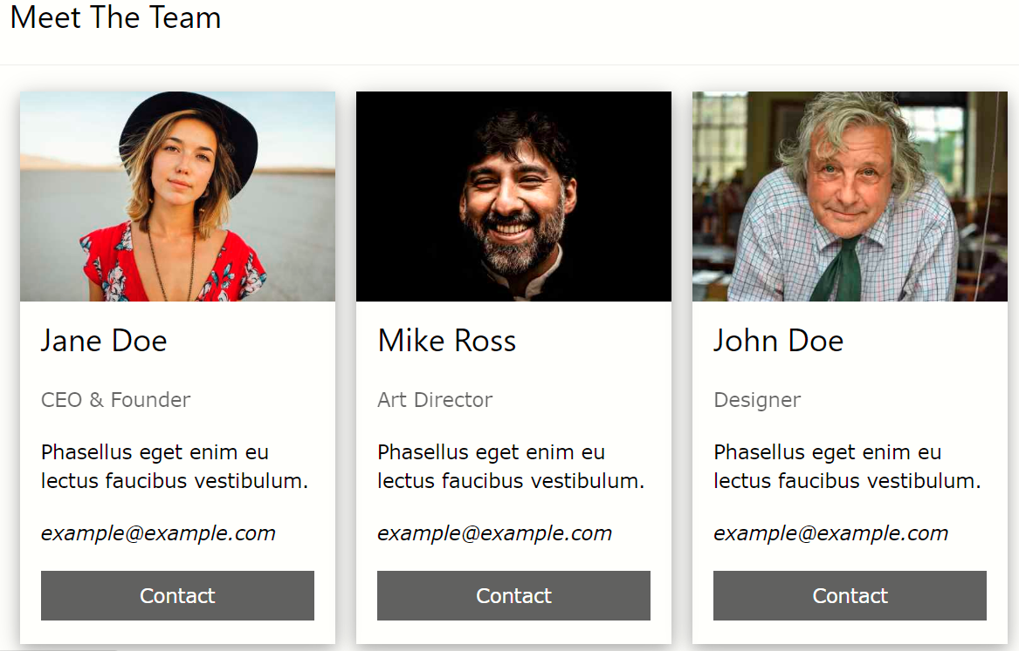

**Coding:**

Go to **QuikLink** visual studio code and then take same parts of the code.

Create the file Employee in the folder of Employees at studio code.

 function getData(url) {

            return $.ajax({

                url: url,

                method: "GET",

                headers: { "Accept": "application/json; odata=verbose" }

            });

        }

        function getQuikLink() {

            var url = _spPageContextInfo.webAbsoluteUrl + "/_api/web/lists/getbytitle('QuikLink')/items";

            return getData(url);

                }

**And then change:**

getQuikLink by getEmployee

QuikLink by Employee

**Add jQuery:**

    <script src="https://ajax.googleapis.com/ajax/libs/jquery/3.4.1/jquery.min.js"></script>

**Copy the code: and paste at home page**

<div id="EmployeeItems">

</div>

<script src="https://ajax.googleapis.com/ajax/libs/jquery/3.4.1/jquery.min.js"></script>

<script>

    function getData(url) {

        return $.ajax({

            url: url,

            method: "GET",

            headers: { "Accept": "application/json; odata=verbose" }

        });

    }

    function getEmployee() {

        var url = _spPageContextInfo.webAbsoluteUrl + "/_api/web/lists/getbytitle('Employee')/items";

        return getData(url);

    }

    $(document).ready(function () {

        //code starts here

        getEmployee().then(function(response){

            //code success starsts here

            console.log(response.d.result);

             //code success ends here

        },function(error){console.error('Oops error',error);});

         //code ends here

    });

</script>

**Edit it on the home page .**

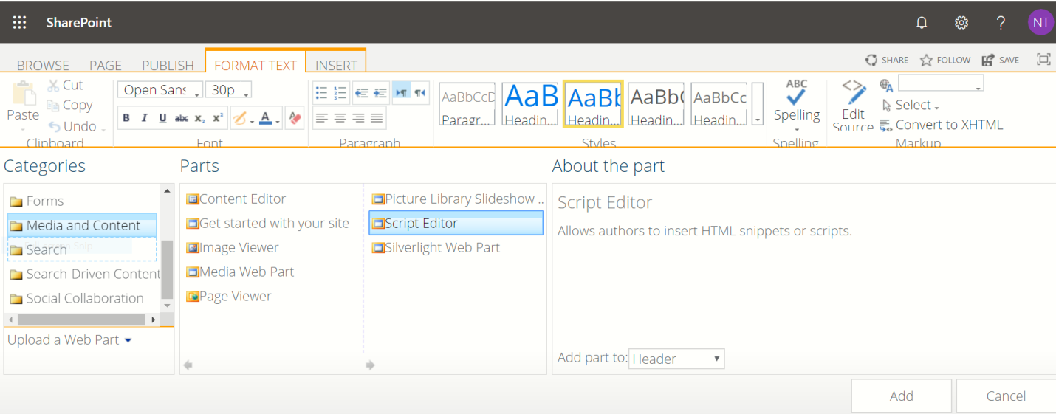

But the revon is sticky so to fix it.

Inspect it at chrome=>

<div id="EmployeesItems"></div>

<script src="https://ajax.googleapis.com/ajax/libs/jquery/3.4.1/jquery.min.js"></script>

<script>

    function getData(url) {

        return $.ajax({

            url: url,

            method: "GET",

            headers: { "Accept": "application/json; odata=verbose" }

        });

    }

    function getEmployees() {

        var url = _spPageContextInfo.webAbsoluteUrl + "/_api/web/lists/getbytitle('Employees')/items";

        return getData(url);

    }

    $(document).ready(function () {

        //code starts here

        getEmployees().then(function (response) {

            //code success starsts here

            console.log(response.d.result)

var items = response.d.result;

var myHthl = '';

//Items.forEach

For(var i in items){

myHtml += ``

}

            //code success ends here

        }, function (error) { console.error('Oops error', error); });

        //code ends here

    });

</script>

Go to BootStrap 4 at card and grap single card image syntax and then put it between bactic( ` `). That is

<div class="card" style="width:400px">  
  <img class="card-img-top" src="img_avatar1.png" alt="Card image">  
  <div class="card-body">  
    <h4 class="card-title">John Doe</h4>  
    <p class="card-text">Some example text.</p>  
    <a href="#" class="btn btn-primary">See Profile</a>  
  </div>  
</div> => **The finally we get:**

<div id="EmployeesItems"></div>

<script src="https://ajax.googleapis.com/ajax/libs/jquery/3.4.1/jquery.min.js"></script>

<script>

    function getData(url) {

        return $.ajax({

            url: url,

            method: "GET",

            headers: { "Accept": "application/json; odata=verbose" }

        });

    }

    function getEmployees() {

        var url = _spPageContextInfo.webAbsoluteUrl + "/_api/web/lists/getbytitle('Employees')/items";

        return getData(url);

    }

    $(document).ready(function () {

        //code starts here

        getEmployees().then(function (response) {

            //code success starsts here

            console.log(response.d.result)

var items = response.d.result;

var myHthl = '';

//Items.forEach

For(var i in items){

myHtml += `<div class="card" style="width:400px">

    <img class="card-img-top" src="img_avatar1.png" alt="Card image">

    <div class="card-body">

      <h4 class="card-title">John Doe</h4>

      <p class="card-text">Some example text.</p>

      <a href="#" class="btn btn-primary">See Profile</a>

    </div>

  </div>

`;

}            //code success ends here

        }, function (error) { console.error('Oops error', error); });

        //code ends here

    });

</script>

**Changes:**

* style="width:400px"> to style="max-width:400px">
* src="img_avatar1.png" to src="${item.picture}"
* John Doe to ${item.Title}
* Some example text. To ${item.ShortDescription}

**Look:**

 var myHthl = '<div class="row">';

            //Items.forEach

            For(var i in items){

            var item = items[i];

            myHtml += `

                <div class="col">

                    <div class="card" style="max-width:400px">

                        <img class="card-img-top" src="${item.picture} "alt="Card image">

                        <div class="card-body">

                         <h4 class="card-title">${item.Title}</h4>

                          <p class="card-text"> ${item.ShortDescription}</p>

                          <a href="${_spPageContextInfo.webAbsoluteUrl + '/lists/Employees/dipform.aspx?id=' + item.ID}"targe ="_blank" class="btn btn-primary">See Profile</a>

                        </div>

                    </div>

                </div>

           `;

        }

       myHtml += '</div>';

        ${'#employeesItems'}.html(myHtml);

///////////////////////////////////

<div id="EmployeesItems"></div>

<script src="https://ajax.googleapis.com/ajax/libs/jquery/3.4.1/jquery.min.js"></script>

<script>

    function getData(url) {

        return $.ajax({

            url: url,

            method: "GET",

            headers: { "Accept": "application/json; odata=verbose" }

        });

    }

    function getEmployees() {

        var url = _spPageContextInfo.webAbsoluteUrl + "/_api/web/lists/getbytitle('Employees')/items";

        return getData(url);

    }

    $(document).ready(function () {

        //code starts here

        getEmployees().then(function (response) {

            //code success starsts here

            console.log(response.d.results)

var items = response.d.results;

 var myHthl = '<div class="row">';

            //Items.forEach

            For(var i in items){

            var item = items[i];

            myHtml += `

                <div class="col">

                    <div class="card" style="max-width:400px">

                        <img class="card-img-top" src="${item.picture} "alt="Card image">

                        <div class="card-body">

                         <h4 class="card-title">${item.Title}</h4>

                          <p class="card-text"> ${item.ShortDescription}</p>

                          <a href="${_spPageContextInfo.webAbsoluteUrl + '/lists/Employees/dipform.aspx?id=' + item.ID}"targe ="_blank" class="btn btn-primary">See Profile</a>

                        </div>

                    </div>

                </div>

           `;

        }

       myHtml += '</div>';

        ${'#employeesItems'}.html(myHtml);

           //code success ends here

        }, function (error) { console.error('Oops error', error); });

        //code ends here

    });

</script>

**EcmaScript(ES)**

EcmaScript (ES) is a standardised scripting language for JavaScript (JS). The current ES version supported in modern browsers(IE) is ES5. However, ES6 tackles a lot of the limitations of the core language, making it easier for devs to code. Let’s take a look at the main differences between ES5 and ES6 syntax.

**ES6 is more readable.**

## Fat Arrow Function (=>) for ES6

**A. Return Number function**

**// ---------- ES5 ----------  
function getNum() {  
 return 10;  
}// ---------- ES6 ----------  
const getNum = () => 10;**

<https://engineering.carsguide.com.au/es5-vs-es6-syntax-6c8350fa6998>

**To convert one to each other**

<https://es6console.com/> Or <https://www.typescriptlang.org/>

by using this converter change ES6 to ES5

**that is:**

     myHtml += `

            <div class="col-sm-3">

              <div class="card">

                <img class="card-img-top" src="${item.Picture}" alt="${item.Title}'s Picture" style="width:100%">

                <div class="card-body">

                  <h4 class="card-title">${item.Title}</h4>

                  <p class="card-text">${item.ShortDescription}</p>

                  <a href="${_spPageContextInfo.webAbsoluteUrl + '/lists/Employees/dispForm.aspx?id=' + item.ID}" target="_blank" class="btn btn-primary">See Profile</a>

                </div>

              </div>

            </div>

          `;

**Then we get the following change. From this we have to delete (*'use strict'***;) we don’t need it.

'use strict'; =>cancel this

myHtml += '\n<div class="col-sm-3">\n<div class="card">\n

<img class="card-img-top" src="' + item.Picture + '" alt="' + item.Title + '\'s Picture" style="width:100%">\n

<div class="card-body">\n

<h4 class="card-title">' + item.Title + '</h4>\n

<p class="card-text">' + item.ShortDescription + '</p>\n

<a href="' + (_spPageContextInfo.webAbsoluteUrl + '/lists/Employees/dispForm.aspx?id=' + item.ID) + '" target="_blank" class="btn btn-primary">See Profile</a>\n

</div>\n

</div>\n

</div>\n';

**Then use it and get the result at the IE.**

**Searching:**

bootstrap 4 search with icon

### Bootstrap 4 text input with search icon – CodePen

<div id="container"></div>

Bb

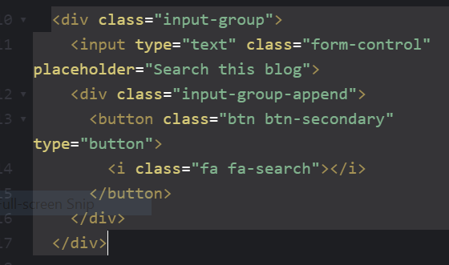

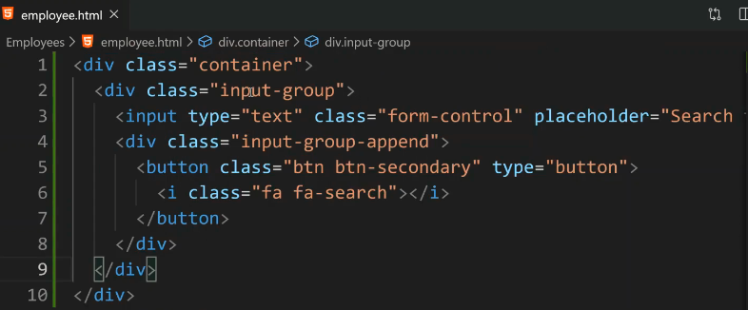

Nn

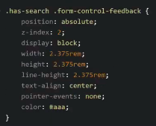

**Nn**

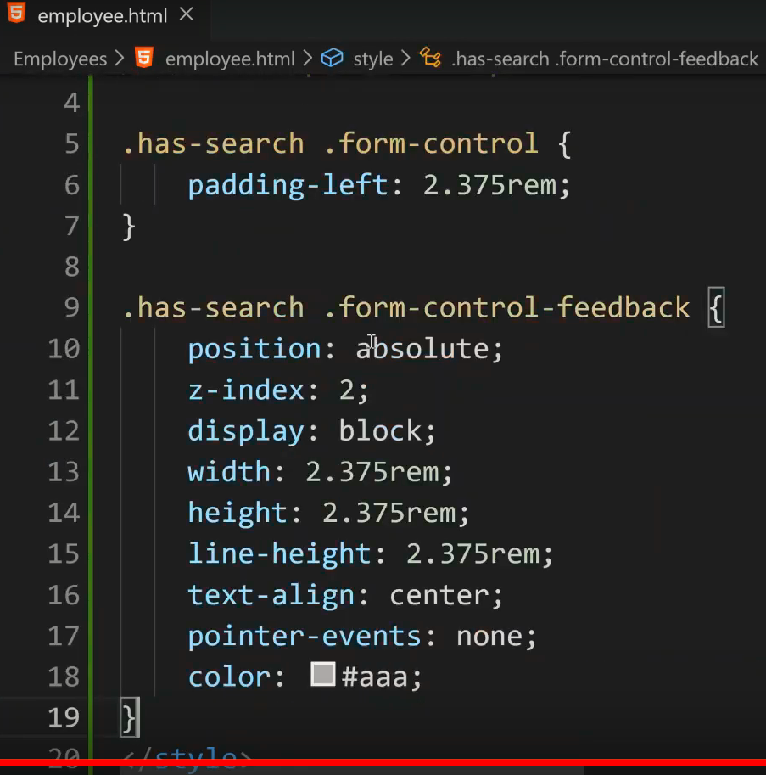

**Or**

<style>

  .has-search .form-control {

    padding-left: 2.375rem;

}

.has-search .form-control-feedback {

    position: absolute;

    z-index: 2;

    display: block;

    width: 2.375rem;

    height: 2.375rem;

    line-height: 2.375rem;

    text-align: center;

    pointer-events: none;

    color: #aaa;

}

</style>

**Take the following list from the following chart:**

**https://cdnjs.cloudflare.com/ajax/libs/font-awesome/4.7.0/css/font-awesome.min.css** 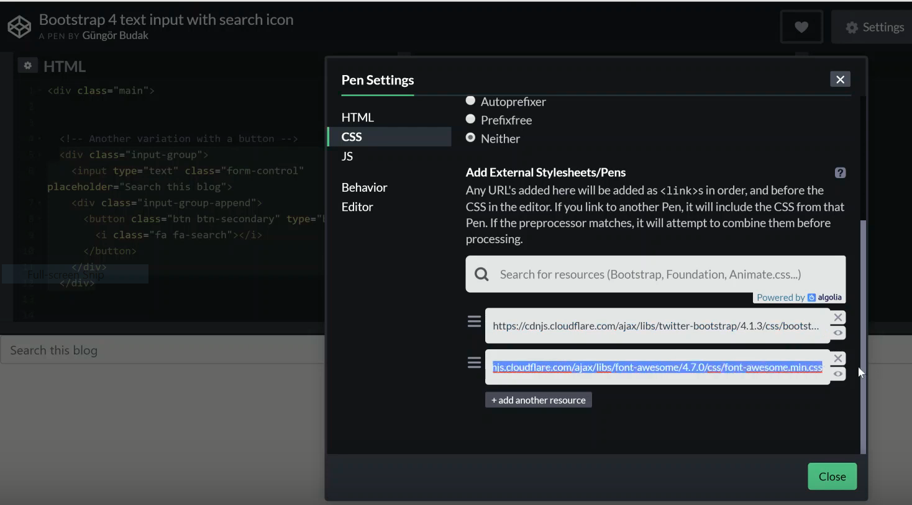

**put**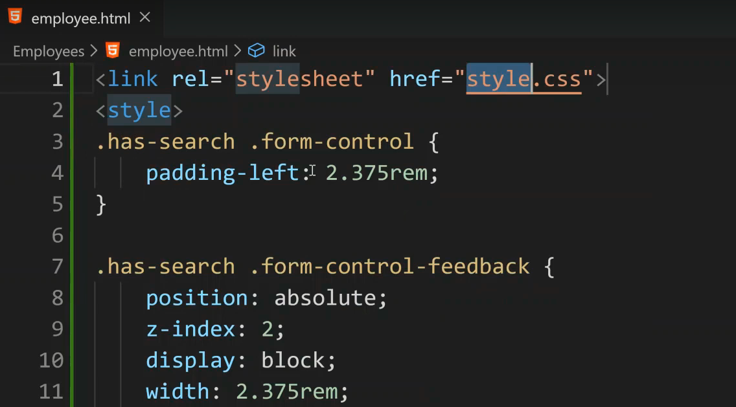

**Make like this:**

<link rel="stylesheet" href="https://cdnjs.cloudflare.com/ajax/libs/font-awesome/4.7.0/css/font-awesome.min.css">

<style>

**Copy this link :**

<https://maxcdn.bootstrapcdn.com/bootstrap/4.4.1/css/bootstrap.min.css>

**from**

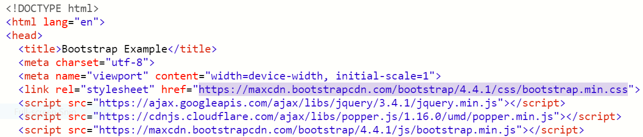

**copy**

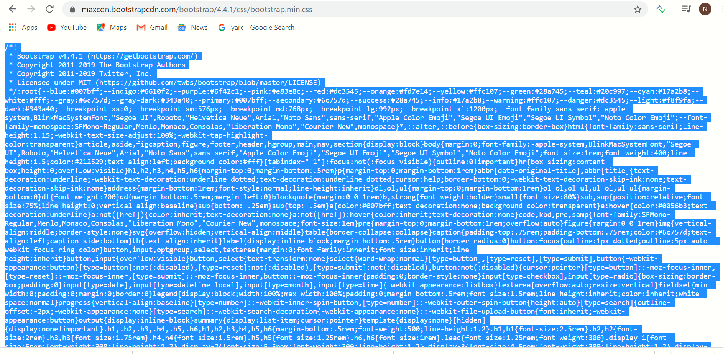

**Paste instead**

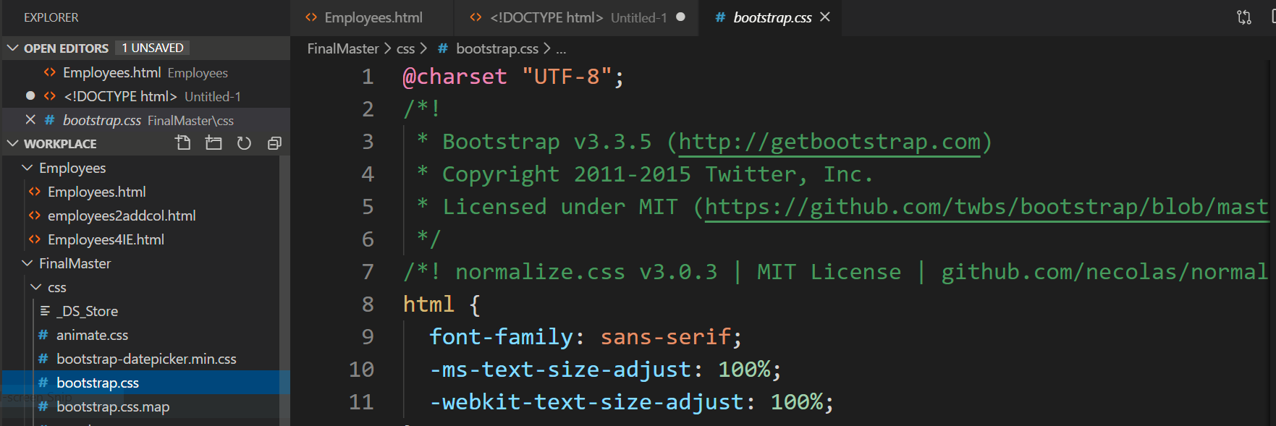

Then we get:

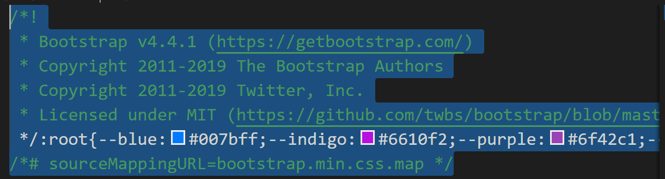

**And then refresh our publish page. Then we get**

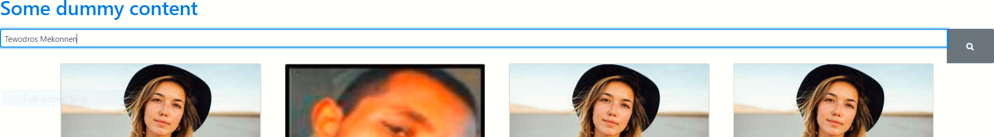

**Activated the search**:

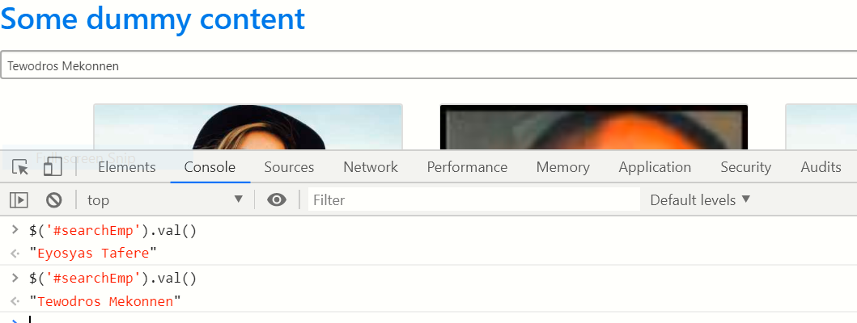

**Open API(YARC)and search the iten by using the following link**

https://nmek.sharepoint.com/sites/2019Publish/_api/web/lists/getbytitle('Employees')/items?$filter=Title eq 'Tewodros Mekonnen'

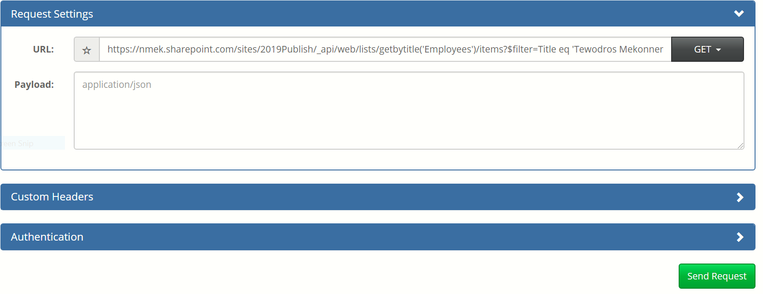

Then we get

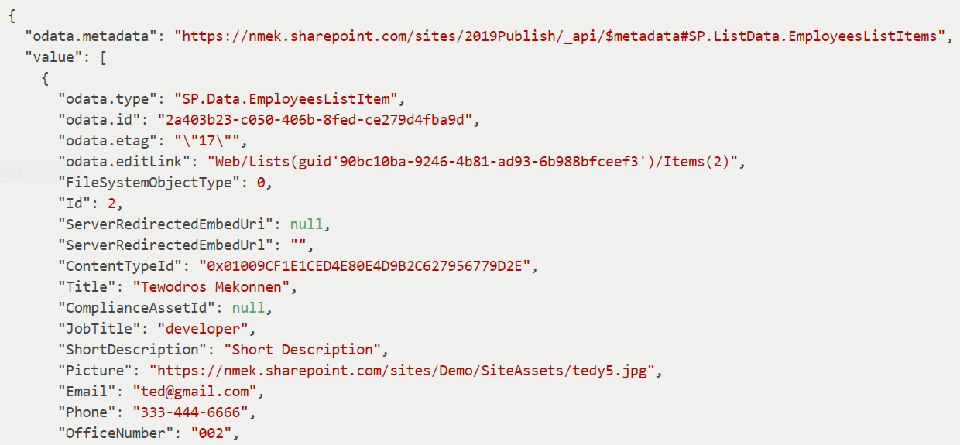

Then we need to use the link to our publishing search

**Using icons:**

1. Fontawesome icons:
2. Bootstrap icoms
3. ui fabric/icons

**Forntawesome:**

font awesome icons

### [Font Awesome Icons - Icons | Font Awesome](https://fontawesome.com/icons?from=io)

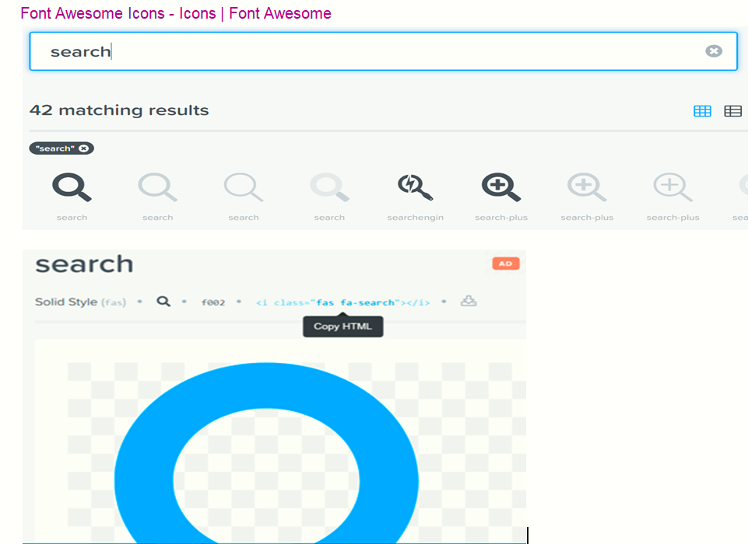

**That is This:** <i class="fa fa-search"></i> Look this in our code. You see

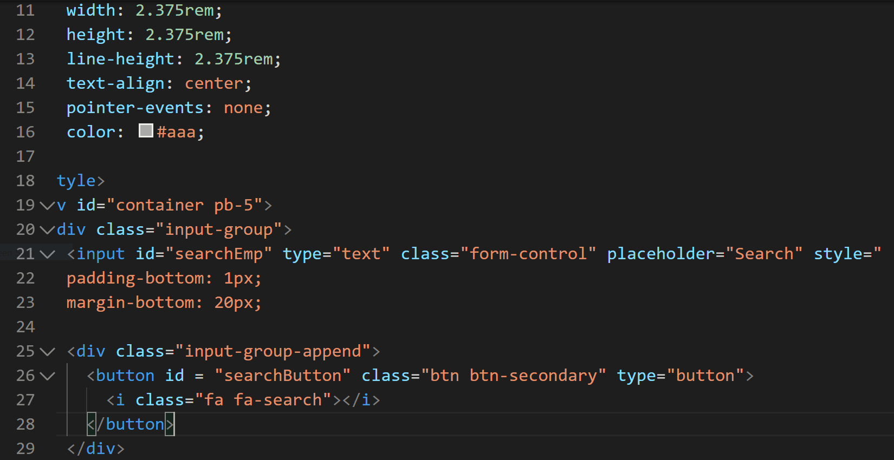

**End of class 24**

**==================///=====================**